Social SEO Takeover Document – 2025 Sept – Dec

Social SEO 交接文件 – 2025 9-12月
  - Alick Li 哈基迷
December 10th, 2025

Table of Contents
All links used inside this file 1
Introduction and Troubleshooting & 内容介绍 & 故障排除 2
Website Basic Maintenance & Updates: 3
WordPress Admin Account Login 3

All links used inside this file are listed here:
• Greenwave China: www.greenwavechina.cn
• Clean Water Restaurant: www.cleanwaterrestaurant.cn
• Baota Extranet panel address: 8.155.40.44:13663/064c650d
• Baota Intranet panel address: 172.17.138.232:13663/064c650d
• Greenwave China WordPress admin page: https://www.greenwavechina.cn/wp-admin/
• Clean Water Restaurant WordPress admin page: https://www.cleanwaterrestaurant.cn/wp-admin/
• Aliyun (Alibaba Cloud): https://www.aliyun.com/

Introduction and Troubleshooting & 内容介绍 & 故障排除

This is a handover file for the basic maintenance & update operations of the website, which only includes:
- All the daily operations for Greenwave China’s two websites, except for SEO development:
  - Greenwave China, Clean Water Restaurant
- Maintenance operations of Aliyun’s server for the two websites above ⬆️
- Domain name
- Email Sending (SMTP)
And DOES NOT include:
- ANY of the social media operating instructions (e.g. Douyin, Xiaohongshu, etc.)
- ANY of the SEO operating instructions, if you want to find the instructions about SEO development, please go to the document Greenwave Website Seo Take Over 网站SEO交接工作.pdf instead.

If there is anything unclear, try to find tutorials inside the plugins of WordPress, and tutorial videos on LinkedIn Learning or YouTube, or contact me by WeChat: 13178820821, email: junchen.alick.li@gmail.com or (+1) 4373638818

Website Basic Maintenance & Updates:
This section includes ALL the operations for websites maintenance:
- Log in to the WordPress admin account

WordPress Admin Account Login
Here are the two admin account links for Greenwave China’s two websites:
Greenwave China: https://www.greenwavechina.cn/wp-admin/
Username: admin
Password: kV&&AF(R%^#Bo7jlgE
Note: The “^” formatting in the PDF may differ from the correct format; manual typing may be required.
注意：^可能在pdf格式中与正确的格式不一致，可能需要手打
Clean Water Restaurant: https://www.cleanwaterrestaurant.cn/wp-admin/
Username: cleanadmin
Password: 3gQX2n#%$oUFW)XfPP

By pasting these two links to the browsers, you’ll get the pages like this:

See the next page: ⬇️

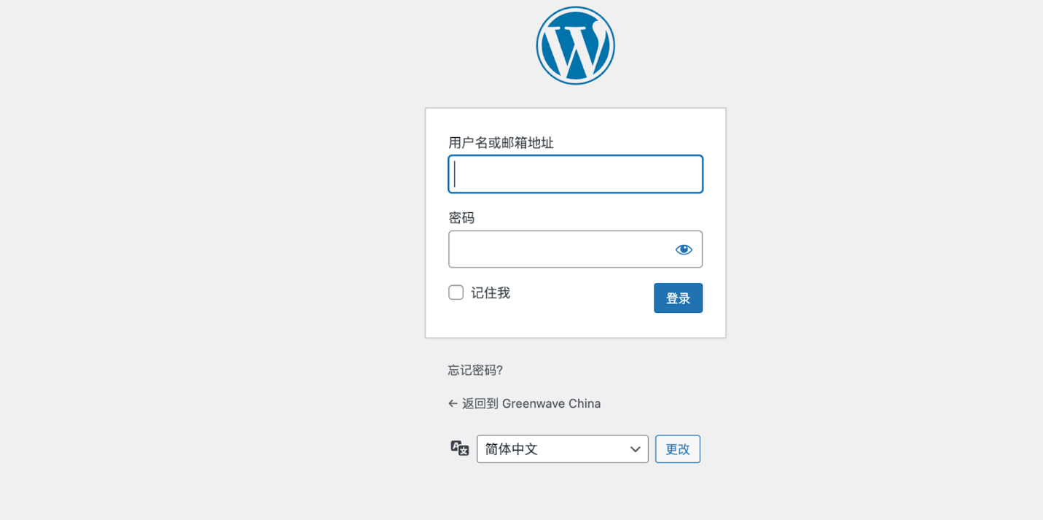

After entering the right username and password, you may get the following window⬇️, Just click the small button “remind me later” / “稍后提醒我”.
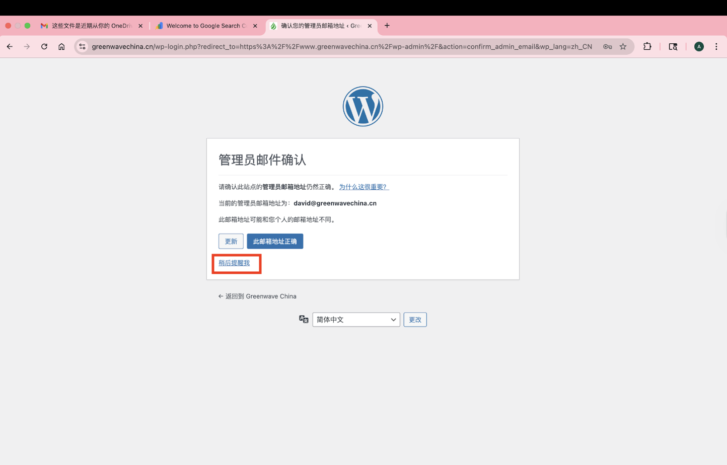

Now, you may successfully log in to the WordPress admin account!

